
Critical Information Summary

Opticomm Plan

Information about the service

Service Description

CityCable Opticomm Plan is a broadband data service that provides you with internet access at your premises via the Opticomm infrastructure.

Service Plan Information
Plan | NBN 25 | NBN 50 | NBN 100 | NBN 1000
Typical downloading speed | 21mbps | 46mbps | 92mbps | 500mbps
Typical uploading speed | 5mbps | 18mbps | 19-38mbps | 48mbps
Standard Monthly Fee | $70.00 | $80.00 | $95.00 | $148.00
Minimum term applicable | No | No | No | No
Data Allowance | Unlimited | Unlimited | Unlimited | Unlimited
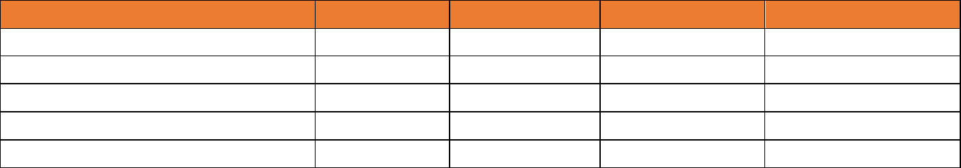
- No minimum contract term for all plans.
- Static IP feature will charge $10/month.

New Site Connection Fee

A new development fee of $300 or $550 ins.GST may be applied – depends on the service address. An extra charge will be applied for an additional connection requiring installation of additional equipment. We will inform you if either of these charges will apply to you and will include them on your bills.

What is the service?

City Cable’s Opticomm Plan service uses Opticomm infrastructure to deliver broadband to your premises. These services provide the typical evening download speeds listed for each plan in the table above.

Other Information

Key Details
This is an internet service that is delivered over
the Opticomm Networks.

Billings
City Cable Opticomm Plan service(s) are charged full month in advance (generally on the 1st of the month) and are non-refundable. We will only pro-rata the fee of the 2nd month to ensure your billing period is adjusted from your commencement date to the 1st of the month.

Payment Method

You can choose to pay for your service by direct debit from your bank account, your nominated credit card or AMEX (1% surcharge will be applied on each AMEX transaction). A dishonor fee of $9.90 will be applied to each declined payment.

Changes to your plan

We may make changes to your plan from time to time, including its pricing and inclusions. Written notice will be provided via Email. Where any changes have a neutral or beneficial impact to you. If there are significant changes applied to your service, we will provide you with at least 30 days’ written notice via email.

Critical Information Summary

Hardware Devices
You must have a compatible router to access to the internet service if you choose not to purchase a router from us.

However, we can only provide limited support to BYO router.

Service Availability

Opticomm services are not applying to all areas. We will need to perform service qualification checks to the nominated site address for broadband service availability. If we are unable to offer you services, we will contact you for further discussion, or if we failed to contact you in reasonable attempts, we will cancel your order.
You may find out if your address is eligible by emailing info@citycable.com.au or call us on 1300 850 718 during our business hours, Monday to Friday, 9:00am - 6:00pm.

Installation and Setup

Standard installation is included. Non-standard installation may incur additional costs. You must be someone over 18 years of age to sign up with CityCable Opticomm Plan and in attendance at the appointment, if required.

Relocation
If you wish to relocate the service, we may be able to provide the same service if the
new location is serviceable and you may incur with some charges if necessary.
A missed appointment fee of $165.00 in.GST will be applied if the service activation or service fault rectification does not proceed at scheduled appointment time, due to act of End-user.

Termination service

You must provide a written notice, (including customer id, name, contact no, service address, termination date and termination reason) 30 days before the next billing cycle. Otherwise, a full month charge will be applied and it is not refundable.

General Enquiry and Complaint

We are committed to providing you with excellent customer service. Please contact us via email to info@citycable.com.au or call us on 1300 850 718 during our business hours, Monday to Friday, 9:00am - 6:00pm if you have any inquiry or would like to give feedback or complain.

Telecommunications Industry

Ombudsman (TIO)

We will do our best to solve your problem during our first contact.

If you are unsatisfied with how your complaint has been handled, you may contact TIO via 1800 062 058 or visit

https://www.tio.com.au/complaints/what-expect

On-site Appointment
Technician of CityCable or the subsidiary company may or may not need to onsite for service activation.
Any subsequent onsite installations necessitated by issues on your end may result in additional charges.
If you request onsite service during the service term and the connectivity issue is found to be attributable to your actions, a fee of $165.00 inc.GST per hour will be incurred.

City Cable Australia Pty Ltd v2024

