
Critical Information Summary

NBN Broadband

Information about the service

Service Description

CityCable NBN broadband is a broadband data service that provides you with internet access at your premises via the National Broadband Network.

Service Plan Information
Plan | NBN 25 | NBN 50 | NBN 100 | NBN 1000
Typical downloading speed | 21mbps | 46mbps | 92mbps | 500mbps
Typical uploading speed | 5mbps | 18mbps | 19-38mbps | 48mbps
Standard Monthly Fee | $70.00 | $80.00 | $95.00 | $148.00
Minimum term applicable | No | No | No | No
Data Allowance | Unlimited | Unlimited | Unlimited | Unlimited
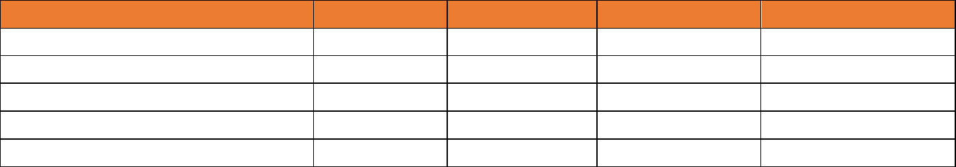

- Information about speeds, please refer to Key Facts Sheet.
- Static IP feature will charge $10/month.

- These plans can include optional single VOIP service. Please call us for more information.

New Site Connection Fee

A new development fee of $300 inc.GST may be applied – depends on the service address. An extra charge will be applied for an additional connection requiring installation of additional equipment. We will inform you if either of these charges will apply to you and will include them in your bills.

VOIP Service

VOIP service with CityCable is a “Pay-As-You-

Go” plan. Additional hardware may be required. Call rates include local call:

$0.25/call; STD: $0.25/min; mobile:

$0.30/min and 13/1300: $0.50/call. A flagfall of $0.30 apply to international call. For international call rate,

please see

https://www.citycable.com.au/index.php/int

ernational-call-rate/

Additionally, you should not regard any VOIP service as a reliable service in an emergency, such as power outage. VOIP service is not recommended if you/other resident have a disability, serious illness or other life-threatening condition necessitating an uninterrupted phone line. Please make sure you have an alternative method to make emergency calls.

Usage and Speed Information

To find out how much data and speed you

need, please see

https://www.citycable.com.au/data-and-speed-estimator/

Other Information

Billings
City Cable NBN service(s) are charged full month in advance (generally on the 1st of the month) and are non-refundable. We will only pro-rata the fee of the 2nd month to ensure your billing period is adjusted from your commencement date to the 1st of the month.

Payment Method

You can choose to pay for your service by direct debit from your bank account, your nominated credit card or AMEX (1% surcharge will be applied on each AMEX transaction). A dishonour fee of $9.90 inc.GST will be applied for each declined payment.

Critical Information Summary

Changes to your plan

We may make changes to your plan from time to time, including its pricing and inclusions. Written notice will be provided via email. Where any changes have a neutral or beneficial impact to you. If there are significant changes applied to your service, we will provide you with at least 30 days’ written notice via email.

Hardware Devices

You must have a NBN compatible modem/router to access to the internet service for BYO router. However, we can only provide limited support to BYO router.

VOIP service is not available for BYO router. You may need to purchase a VOIP Phone Adapter, $99 inc.GST, with CityCable to access to VOIP service.

Service Availability

NBN services are not apply to all areas. We will need to perform service qualification checks to the nominated site address for broadband service availability. The type of service offered the NBN network are FTTP, FTTN, FTTB, FTTC, HFC or FW, and so we may need to perform further qualification checks to determine the type of network for your nominated location. If we are unable to offer you services, we will contact you for further discussion, or if we failed to contact you in reasonable attempts, your order will be cancelled.

Installation and Setup

Standard installation is included. Non-standard installation may incur additional costs. You must be someone over 18 years of age to sign up with CityCable NBN Broadband and in attendance at the appointment.

Relocation

If you wish to relocate the service, we may be able to provide the same service if the new location is NBN serviceable and you may incur with some charges if necessary.

You may check your address here on https://www.citycable.com.au/

Termination service

You must provide a written notice, (including customer id, name, contact no, service address, termination date and termination reason) 30 days before the next billing cycle. Otherwise, a full month charge will be applied, and it is not refundable.

General Enquiry and Complaint

We are committed to providing you with excellent customer service. Please contact us via email to info@citycable.com.au or call us on 1300 850 718 during our business hours, Monday to Friday, 9:00am - 6:00pm if you have any inquiry or would like to give feedback or complain.

Telecommunications Industry

Ombudsman (TIO)

We will do our best to solve your problem during our first contact.

If you are unsatisfied with how your complaint has been handled, you may contact TIO via 1800 062 058 or visit

https://www.tio.com.au/complaints/what-expect

City Cable Australia Pty Ltd v2024-02

